Nov Issue of “Nuclear Engineering International”

PC-based Simulator PCTRAN for GIII Plants

Li-chi Cliff Po

Micro-Simulation Technology,
10 Navajo Court, Montville, New Jersey 07045, USA http://www.microsimtech.com, info@microsimtech.com, Tel 1-973-263-7327

ABSTRACT

The PC-based reactor simulation software PCTRAN was recently expanded to cover light water advanced nuclear power plants. The plant models include Generation III advanced PWR and BWR. The designs are an evolution of Areva EPR and GE ABWR with the addition of cooling path redundancy and devices for severe accident mitigation. One step further is the completely passive-cooled Westinghouse AP1000 and GE/Hitachi ESBWR. Adding severe accident and dose dispersion capability, it forms a suite of training tools aimed to help staff buildup in the revitalized industry.

INTRODUCTION

PCTRAN is a PC-based simulation code using reduced thermal hydraulic nodes for transient prediction. Advanced techniques significantly simplify the numerical solution process. Micro-Simulation Technology (MST) introduced the PC-based transient analyser first in 1985, and it has since then evolved from DOS to the Windows environment. Operation is in standard Windows graphical-user-interface (GUI) with intuitive interactive control.

Useful for training and education of both new engineers as well as seasoned ones adapting to G3 technology, PCTRAN is a “live” simulation tool complementing classroom lectures. Concepts of criticality, feedback, decay heat, etc. can be demonstrated in graphical plant mimics. In addition to normal operation of start-up, power manoeuvre and shutdown, operational transients and accidents can be simulated at speeds many times faster than real-time. The severe accident model allows core-melt and containment failure in the event of multiple failures of the emergency core cooling systems or human error.

In anticipation of a second renaissance of the nuclear era, new constructions will likely advanced models with additional core-cooling redundancy and passive devices. Enhancing the engineered safety devices, various degrees of passive core and containment heat removal systems form the design basis of the G3 reactors. The estimated core degradation frequency (CDF) is reduced by several orders of magnitude down to hundred-millionth (10⁻⁸) per reactor-year.

Since 1996 the International Atomic Energy Agency (IAEA) has selected PCTRAN as the training material in its annual Advanced Reactor Simulation Workshop. Over the years numerous organizations all over the world have licensed various models of PCTRAN.

WINDOWS BASED SIMULATION SYSTEM

Different from replica simulators that were typically developed on individual vendors’ proprietary platforms, PCTRAN is implemented in an industry standard language, Microsoft Visual Basic. User operation follows from the Windows XP/Vista environment. Data input and output are in Access database format. Equipment malfunctions and accident types are selected from a drop-down menu. They include all possible disturbances to a plant:

- Normal operation control – start-up, shutdown, power ramp
- Loss-of-coolant-accident (LOCA) or steam line break
- Loss of flow, single or two-phase natural circulation
- Turbine trip with or with bypass, station blackout
- Steam generator tube rupture (PWR)
- Feedwater transients (pipe break, loss of feed or loss of heating)
- Inadvertent rod insertion/withdrawal
- Anticipated transient without scram (ATWS)
- Containment failure (failed isolation or containment breach)
- Loss of AC power (loss of offsite grid and loss of diesel emergency power)
- Any combination of the above

Execution defaults to real-time speed and may be accelerated to 2, 4, 8 or up to16 times faster for long transients. All automatic and manual actions are recorded in a log text file. Transient curves can be conveniently transferred through Office Suite over a network. Online help is provided to complement the comprehensive users manual for easy instruction.

PC-base simulators for four vendors’ designs have been developed: AREVA EPR, GE ABWR, Westinghouse AP1000 and GE ESBWR. Fidelity of each model is assured by benchmarking against the vendor’s design certification posted by the US Nuclear Regulatory Commission (NRC) in its electronic ADAMS website. Each model’s demonstration version as well as the benchmark analysis can be downloaded from MST’s website. The demo version is similar to the actual product but has a limited runtime.

In order to cover radiological safety all the way from the fuel element to general public, severe accident and offsite dispersion is integrated into each simulation system. Following are descriptions of each plant model. Only those “advanced” concepts and passive systems are mentioned in this article.

Areva EPR

The AREVA designed EPR is advanced from their 4-loop plant. The reactor thermal power is 4300 MW (1600 MW electric). There are four trains of independent emergency core cooling systems and double containment for improved safety. The major components – the pressure vessel and its internals, the steam generators and the primary coolant pumps – are designed to provide modest response during disturbance from normal operation.

Detecting a loss-of-coolant accident, (LOCA) the Safety Injection System (SIS) is actuated in the same manner as conventional PWR. The advanced concept of using the main steam relief train (MSRT) to rapidly de-pressurize the steam generators is adopted. This allows the reactor’s primary coolant to depressurise as well so that the medium head safety injection (MHSI) could inject coolant makeup to prevent core exposure. Another feature is moving the refuelling water storage tank (RWST) inside the containment so that it provides a large reservoir of water for post accident re-circulation.

MSRT can be initiated relatively easily in PCTRAN. In the following figure a single automated command has changed the steam relief valve’s setting to reach 100ºC/hr cooldown rate and depressurise the steam generators within 20 minutes.

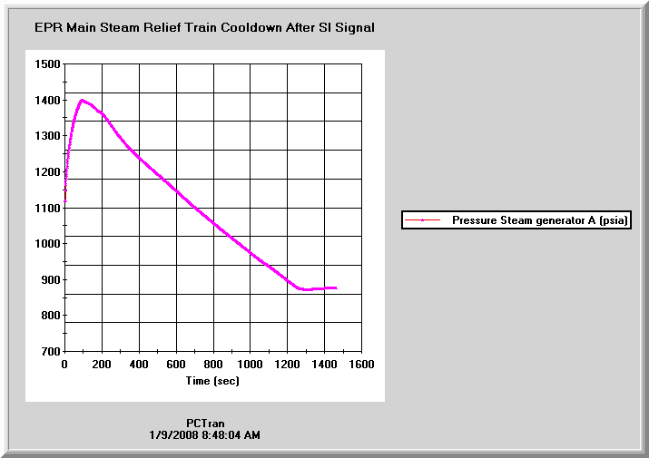

EPR’s main steam relief train function to mitigate a loss of coolant event

EPR has a unique design for severe accident mitigation. Should core melt occur, the corium debris would be collected and cooled in a specially designed spreading area located underneath the reactor vessel. It is simulated in the PCTRAN/EPR severe accident model.

Westinghouse AP1000

Westinghouse AP1000’s nuclear and secondary steam supply system (NSSS) is similar to a conventional PWR. The core is rated 3400 MWt (1100 MW electric). The reactor’s primary coolant has two steam generators with four coolant pumps (2x4 configuration). The PCTRAN mimic’s right hand side control panels are for normal operation. There are rod control system, pressurizer and steam generator pressure and level controls to keep the plant at desired operating condition. The Chemical and Volume Control System (CVCS) panel is located in the lower left. It is composed of charging pumps and letdown valves for reactor coolant purity and inventory control - the same as conventional PWR.

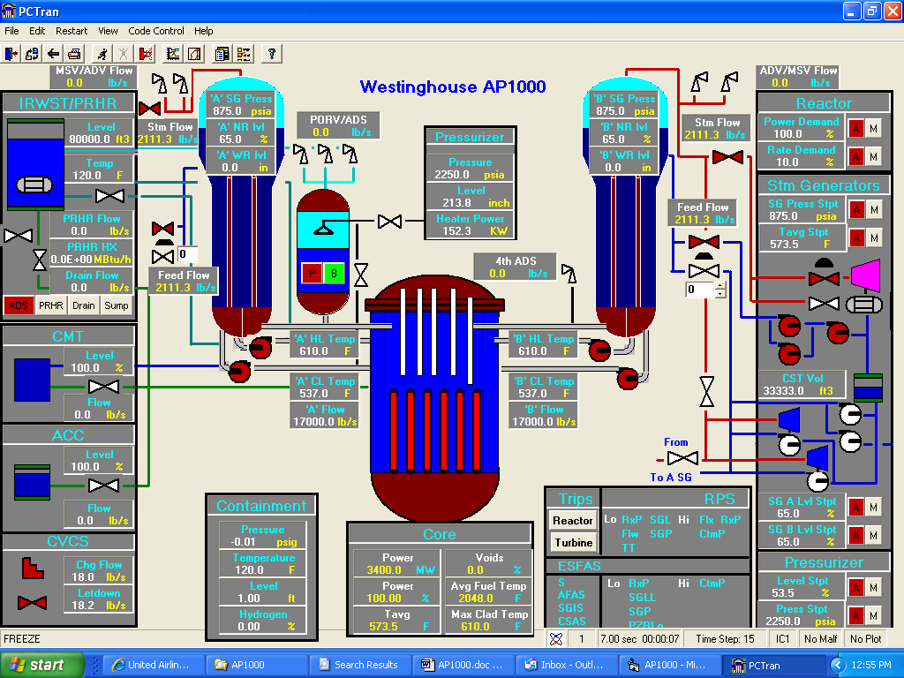
Westinghouse AP1000 NSSS PCTRAN mimic

At left are panels for the passive emergency core cooling systems. At top is the In-Containment Refueling Water Storage Tank (IRWST). Two Passive Residual Heat Removal (PRHR) heat exchangers are submerged in the IRWST. Instead of an active high-pressure injection system that requires safety-graded pumps and emergency AC power supply, passive systems of Core Makeup Tanks (CMT), Accumulators (ACC) and drain valves from the IRWST are provided. Depending upon the extent of pressure reduction following a LOCA, the CMT, ACC and IRWST drain are initiated in sequence to provide coolant makeup into the core.

Three stages of Automatic Depressurisation System (ADS) on top of the pressurizer are provided to relieve steam into the IRWST. The fourth-stage ADS valves are connected to the hot legs and relieve steam directly into the containment atmosphere. They are opened in sequence during a small break loss-of-coolant accident to accelerate depressurisation.

For containment cooling the reactor building is designed as a Passive Cooled Containment System (PCCS). Different from conventional PWR, the containment spray is applied on the outside shell of a steel lining. The PCCS water storage tank is located at the top of the concrete structure. For a design basis scenario, it is activated in the event of high-pressure reading within the containment. It would take place if the normal heat removal (the containment fan coolers) unavailable for an extended period of time. The heat transfer is enhanced by a water film formed by gravity drain of water onto the containment shell. The tank has sufficient water to provide three days of cooling. The atmosphere is the ultimate heat sink for the reactor system. In PCTRAN AP1000 containment mimic, the valve colour changes and digitally displayed flow rate indicates activation of the passive systems. The containment concrete structure with the baffle provides for natural circulation of outside air. The air enters into the gap between the concrete containment and the baffle at the top, flows down the outside of the baffle, and rises up along the steel containment vessel. The heat is thus transferred through the containment vessel to the environment.

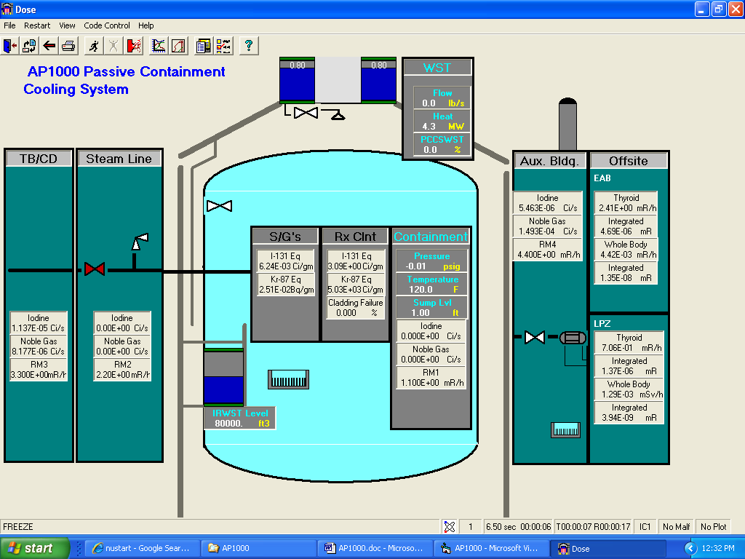

Westinghouse AP1000 PCTRAN Passive Cooling Containment Mimic

The South African utility Eskom is in a process of acquiring either PCTRAN’s EPR or AP1000 model for its pending order of the selected plant type. They recognize the value of the simplified but robust tool during the imminent construction and staff build-up process.

GE ABWR

General Electric (GE) designed Advanced Boiling Water Reactor (ABWR) units have been in operation for many years in Japan. Two more units are under construction in Taiwan. The 1350 MW electric ABWR has evolved from BWR6 by eliminating the external recirculation pumps. The reactor uses 10 reactor internal pumps (RIP) that reduce probability of external pipe break. A containment overpressure protection system is added to mitigate consequence of a severe accident. In the ABWR mimic four of the RIP’s are grouped at left and six remainders at right. At right the Residual Heat Removal (RHR) pumps can be used for low-pressure fill, shutdown cooling, containment spray and suppression pool cooling according to the plant condition.

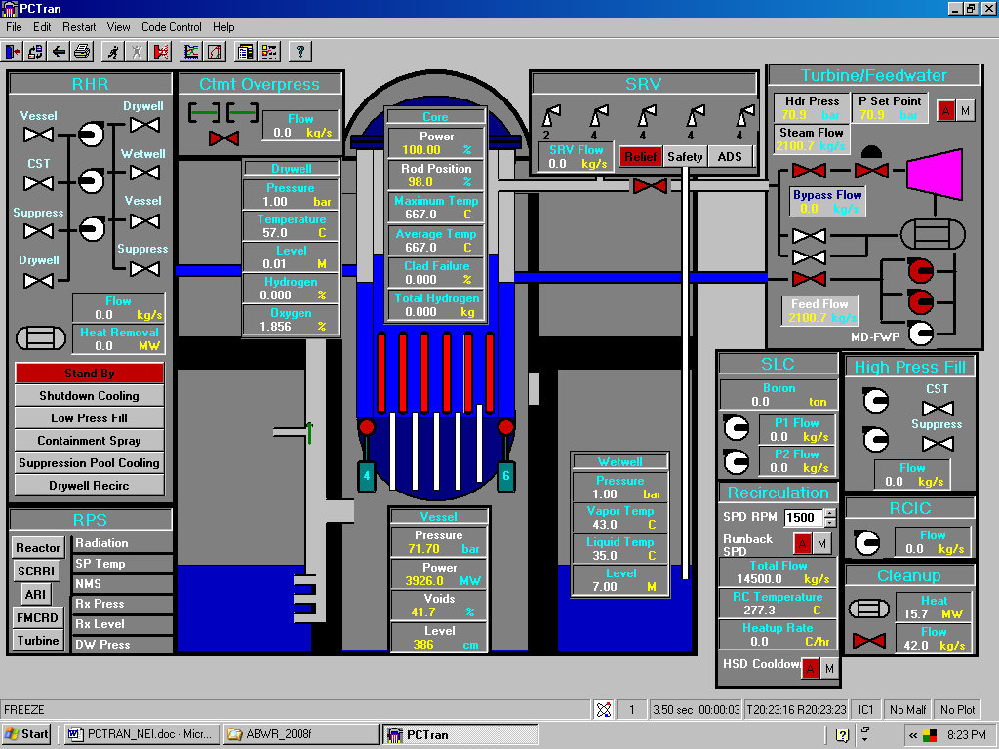

General Electric ABWR PCTRAN NSSS Mimic

MST has developed PCTRAN/ABWR for Taiwan Power Company’s Lungmen Project. The model was also licensed to Taiwan’s National Tsinghua University and Institute of Nuclear Energy Research (INER). INER has integrated the PCTRAN model with Lungmen’s actual digital instrument and control (I&C) system. In the photo below PCTRAN/ABWR was used as the Lungmen Plant to drive the feedwater system and high-pressure core flooder (HPCF) control cabinet. Software failure modes and its reliability can be detected during dynamic simulation.

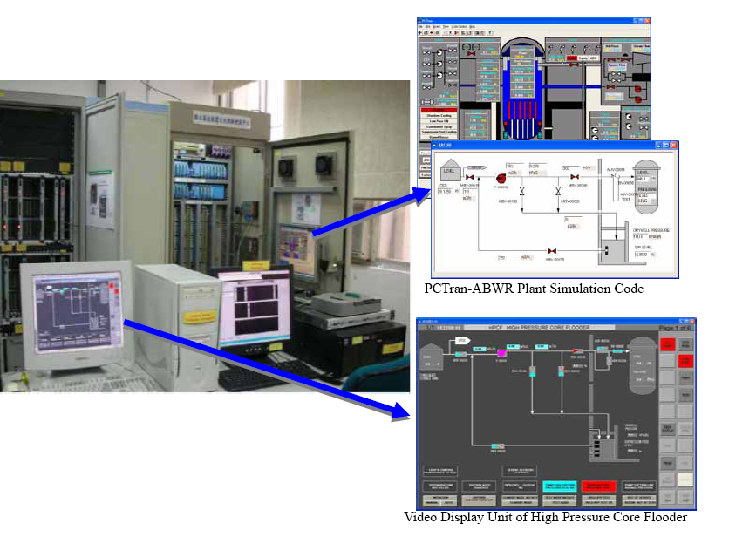
PCTRAN used in ABWR’s I&C software validation and verification in Taiwan

GE/Hitachi ESBWR

The General Electric Economic Simplified BWR (ESBWR) relies on the use of natural circulation and passive safety features to enhance the plant performance and simplify the design. It was based on the earlier Simplified BWR (SBWR) by economics of scale to a higher power level of 4500 MWt (1560 MW electric). The use of recirculation pumps in previous BWR models or reactor internal pumps for ABWR is completely eliminated. Core flow is by natural circulation.

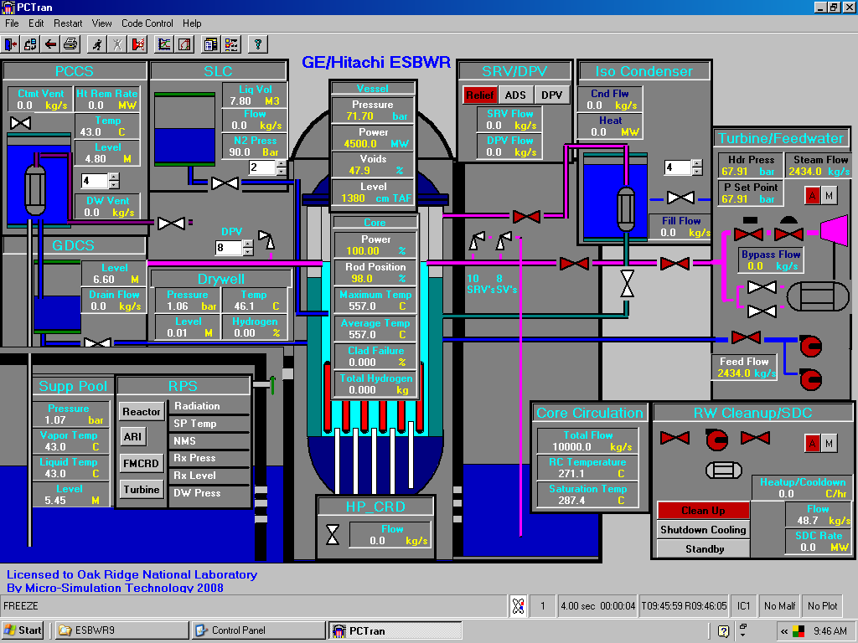

PCTRAN/ESBWR Main Mimic

Normal operation is by the control rod drive system. Since there is no circulation pump for the core flow control, the flux-flow map is a simple natural circulation curve. Natural circulation is further used for emergency core cooling and containment cooling. In the event of steam line leak or break, the reactor is shutdown by inserting all control rods from the bottom. The feedwater continues to maintain the water level in the vessel. The core and containment cooling systems are completely "passive", i.e. without using AC-driven pumps and controls.

In the event of AC power is lost, the ESBWR utilizes the Isolation Condenser System for high-pressure inventory control and decay heat removal. Ten safety relief valves (SRV’s) proved pressure relief function to discharge steam to the suppression pool. They will open upon a low reactor water level signal for Automatic Depressurisation System (ADS) function. Eight Safety Valves and Depressurisation Valves (DPVs) provide further relieve by discharging steam to the drywell.

Containment cooling is provided by the Passive Containment Cooling System (PCCS). The system contains six loops; each has a heat exchanger open to the containment, a condensate drain line and a vent discharge line submerged in the suppression pool. The PCCS limits containment pressure to 40 psig (about 3.6 atmospheres). The passive systems have been successfully analysed to maintain the fuel covered at all time (without heat-up) and the containment stay cooled for three days.

The Advanced Reactor Systems and Safety (ARSS) group of Oak Ridge National Laboratory has acquired a license of PCTRAN/ESBWR. The group is commissioned by US Nuclear Regulatory Commission to review all vendors’ design certifications. South Texas Project (STP) has ordered ABWR from Toshiba for its Unit 3 and 4 constructions. The company has contacted MST and currently is seriously evaluating an acquisition.

Severe Accident Model

A severe accident is defined as beyond design-basis with significant core damage and containment failure. A borderline is usually set in probability safety assessment (PSA) Division 2 for top of the fuel (TAF) uncovery, and Division 3 for fission product relocation.

The core is modelled into six vertical nodes. Each one will generate a portion of the decay heat. When the boundary heat removal rate is less than the core heat, the core node is heated up to the point of melting. Molten fuel may collapse into the bottom of the vessel. The vessel lower head may then heat up to the melting point, too. The molten debris may break the vessel bottom and drop into the containment cavity floor. During the fuel damage process, first the fission gas in the clad may leak out. Later if the fuel and cladding continue their degradation, fuel isotopes will release also. In addition to iodine and noble gases, there are alkali metals, tellurium, barium, cerium, lanthanides, etc. The elevated concentration of these radioactive isotopes would find their ways through the vessel break, relief valves, and containment leakage into the environment.

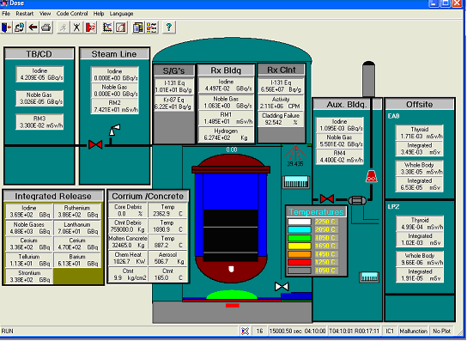

PWR severe accident showing vessel penetration and CCI in progress

Offsite Dose Dispersion

Using PCTRAN-generated radiological release source term, Tsinghua University has successfully developed an add-on of offsite dispersion model. The Gaussian puff model was used with numerical techniques to calculate the radioactive effluent dispersion. During a transient simulation, puffs are sequentially generated and dispersed in all directions governed by the Pasquill stability category, wind velocity and wind direction. The thyroid and whole body dose rate (as well as their accumulations) at downwind spatial location in the neighbourhood are shown as a colour-shaded plot.

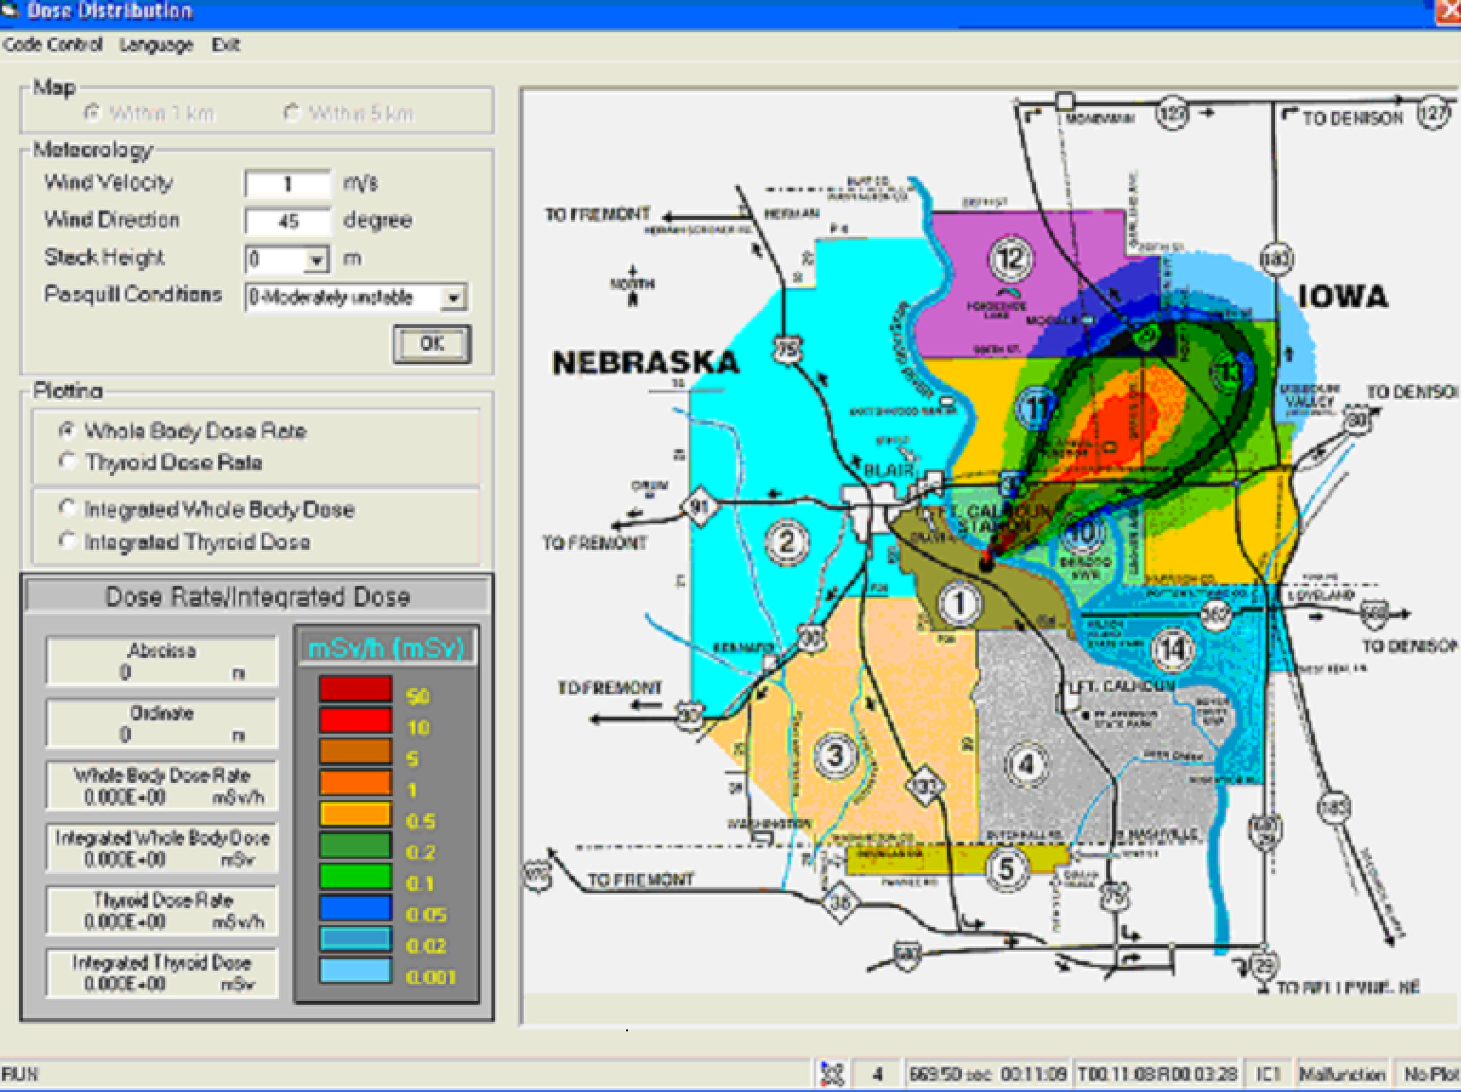

Offsite Dose Dispersion in Fort Calhoun’s Emergency Planning Zone

The releases of radioactive materials are treated as unsteady emissions in non-homogeneous dispersion conditions. The meteorological condition can vary between Pasquill stability category A (most unstable) to F (most stable), wind speed in meters per second and release elevation from ground up to a few hundred meters. The Gaussian puff model is used to predict the time-varying dose distributions. It is more realistic than the Gaussian plume model that assumes the emission is continuous and constant in steady-state meteorological conditions. The model describes the effluent dispersion in the horizontal and vertical directions. It is two-dimensional semi-infinite sphere with elevated release. The projected dose rate and integrated dose are used for emergency activation level determination and recommendation of shielding or evacuation during an exercise.

The severe accident and dose dispersion models have been licensed to Fort Calhoun Station in Omaha, Nebraska. Being a 500MW conventional C-E designed PWR, FCS is not one of the G3 plants. But Omaha is the first utility company to use the PCTRAN integrated simulation tool to support its emergency preparedness and severe accident management guideline (SAMG). The Institute of Nuclear Power Operation (INPO) has recently observed one exercise. The scenario involved core meltdown, hydrogen explosions and succeeding controlled mitigation. The observers took note that this exercise has gone far beyond traditional scenarios dictated by stationery transcripts. Dynamic and active control in the operations side has expanded the scope to a new dimension.

The PCTRAN suite forms a complete training platform for nuclear safety. Prior to a replica simulator being built, or even afterwards, it provides a dynamic tool for the technical staff to familiarize with a plant’s design and operations. The tool, in fact, goes beyond operator training by supporting other use cases, such as engineering scoping study, risk assessment by consequence projection, and emergency preparedness.

